Survivors of assault and abuse often live in constant fear. Their days are filled with anxiety, knowing that their abuser or attacker might strike again. Sadly, this is a scenario many Iowans face every day. More than 3,000 convictions for domestic abuse, sexual assault and stalking transpired in 2017. Many of us know someone who is a victim of one of these heinous crimes, or perhaps you are even a survivor yourself.
In recognition of Sexual Assault Awareness Month this April, we would like to notify you of one resource that is available in Iowa. Safe at Home (SAH) is an address confidentiality program for survivors of domestic violence, sexual assault, trafficking, stalking, and other violent crimes. Participants are assigned a substitute legal address that they can use in place of their actual, physical address. The Safe at Home program forwards the mail to their actual address. The intent of the program is to keep participants’ addresses from appearing on public records.
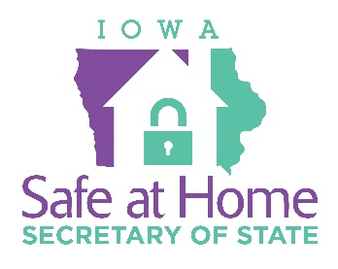
Participants in the program can engage in civic activities such as voting via absentee ballot, obtaining a driver’s license, and registering their children for school, while still ensuring their address remains private. The SAH program is most effective for participants who have recently relocated, as it is not possible to redact addresses that are already listed on public records.
Please help spread the word about Safe at Home. If you or someone you know are interested in hearing more, contact the SAH office at SafeAtHome@Iowa.gov or 515-725-SAFE. To print out an application, visit the SAH website at http://safeathome.iowa.gov/. To speak with a sexual assault/domestic violence advocate, contact the Iowa Victim Service 24-Hour Helpline at 1-800-770-1650 or text IOWAHELP to 20121.

